**SimAgile BAAT Execution 1 Report - Team Based Response (40 Points)**

***Please use the following link to access SimAgile:*** [***http://agile.simproject.com/***](http://agile.simproject.com/)***. Complete an execution from beginning to end and answer the questions that follow. If the above link doesn’t work, try opening the link in private browsing mode.***

***Important Note: if you receive an error while using SimAgile, please try rebooting your computer. If the problem isn’t fixed, please send an email to*** [***support@simulationpl.com***](mailto:support@simulationpl.com)***.***

**Sprint 1 - Week 1 and Week 2 (10 Points)**

**Product Backlog (one screen shot for sprint 1)**

* Paste a screen shot of your product backlog prior to starting sprint 1.

**Answer**

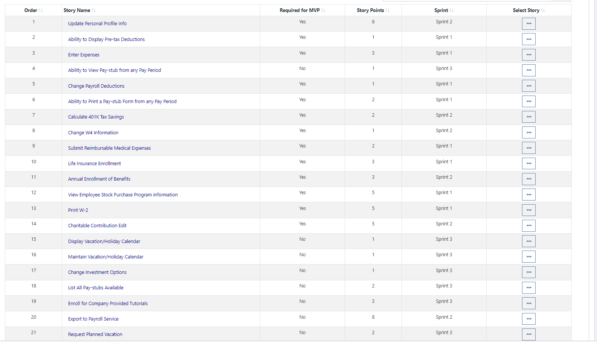

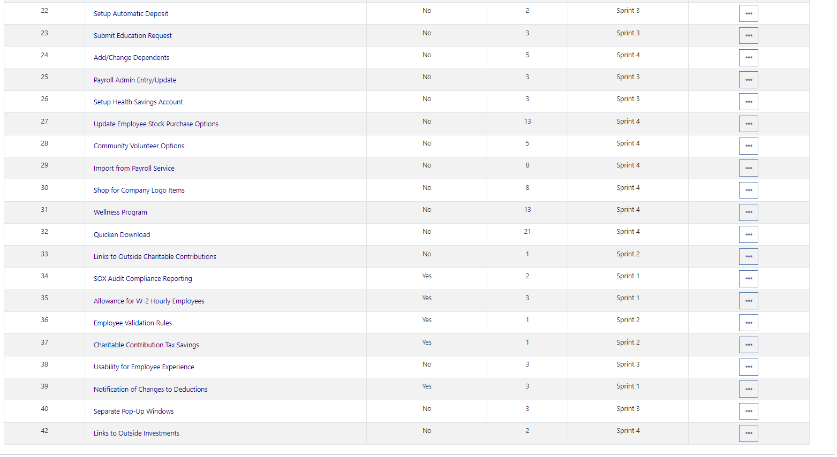

* Please explain what you did in grooming the user stories in your product backlog and your reasoning for these decisions.

**Answer**

**Siian**

**Scrum Board**

Scrum Board screen shot before sprint 1 has started

**Answer**

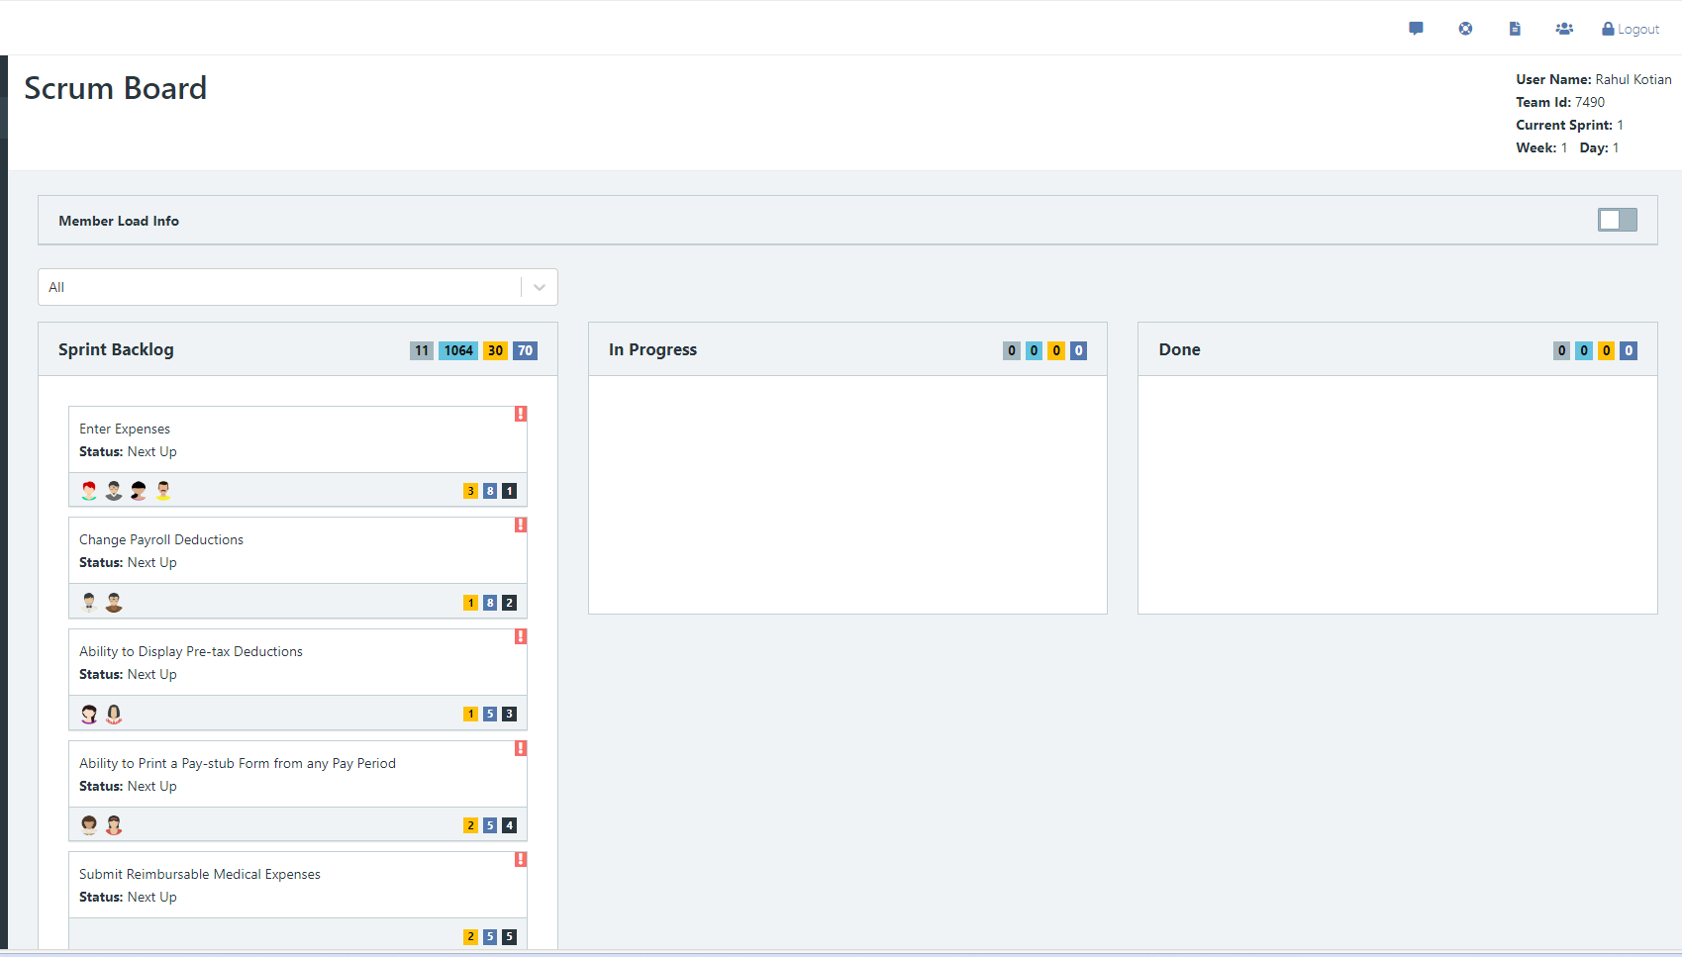

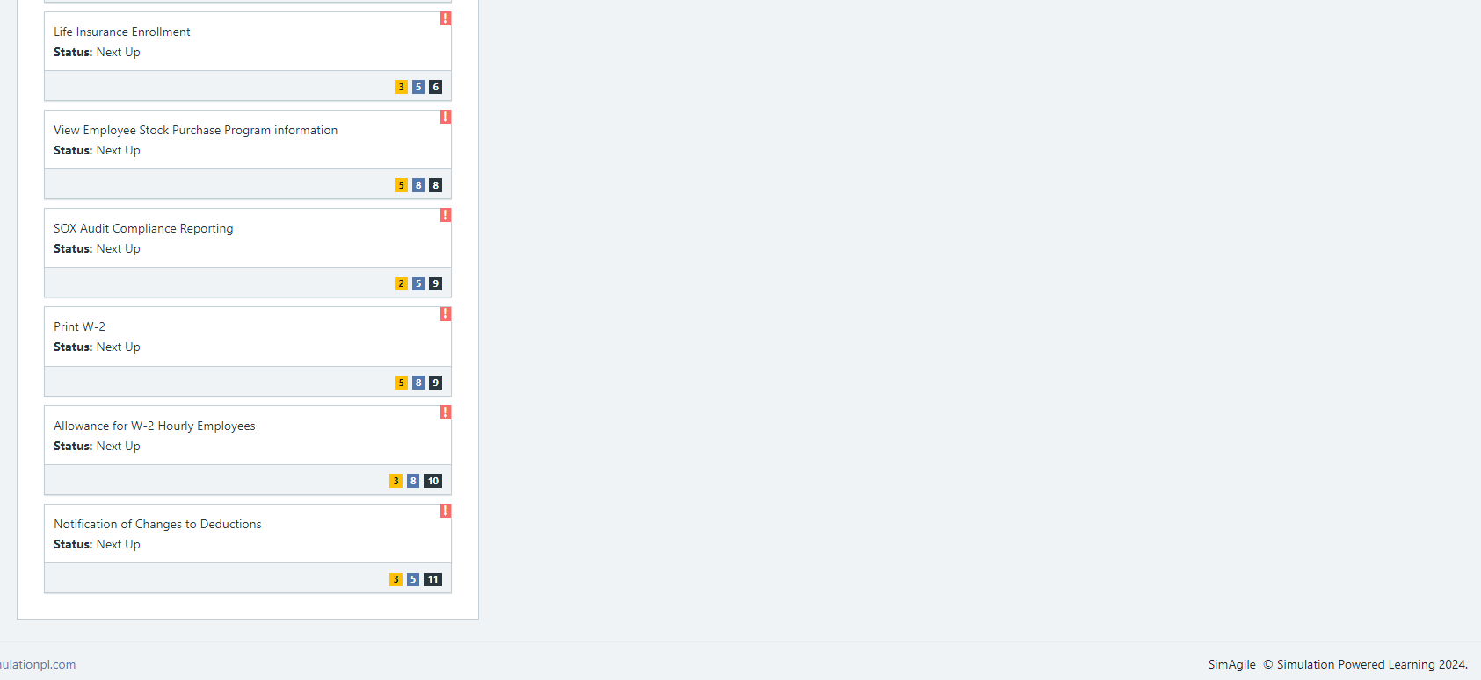

Scrum Board screen shot after 1st week of sprint 1

**Answer**

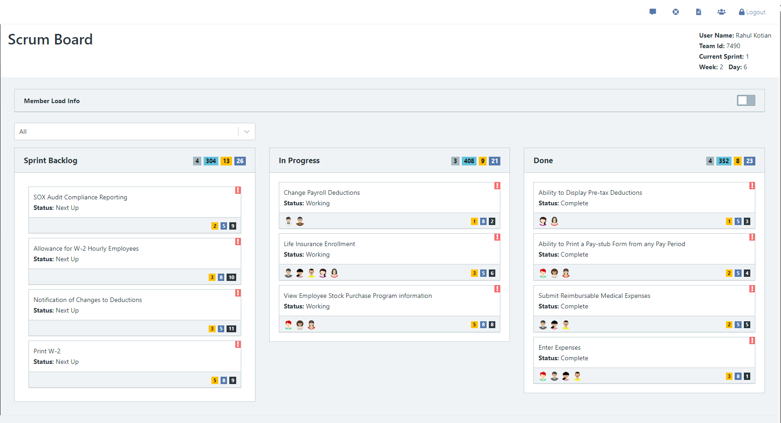

Scrum Board screen shot after 2nd week of sprint 1

**Answer**

**Missed .**

**Calendar**

Paste a screen shot of your calendar for sprint 1

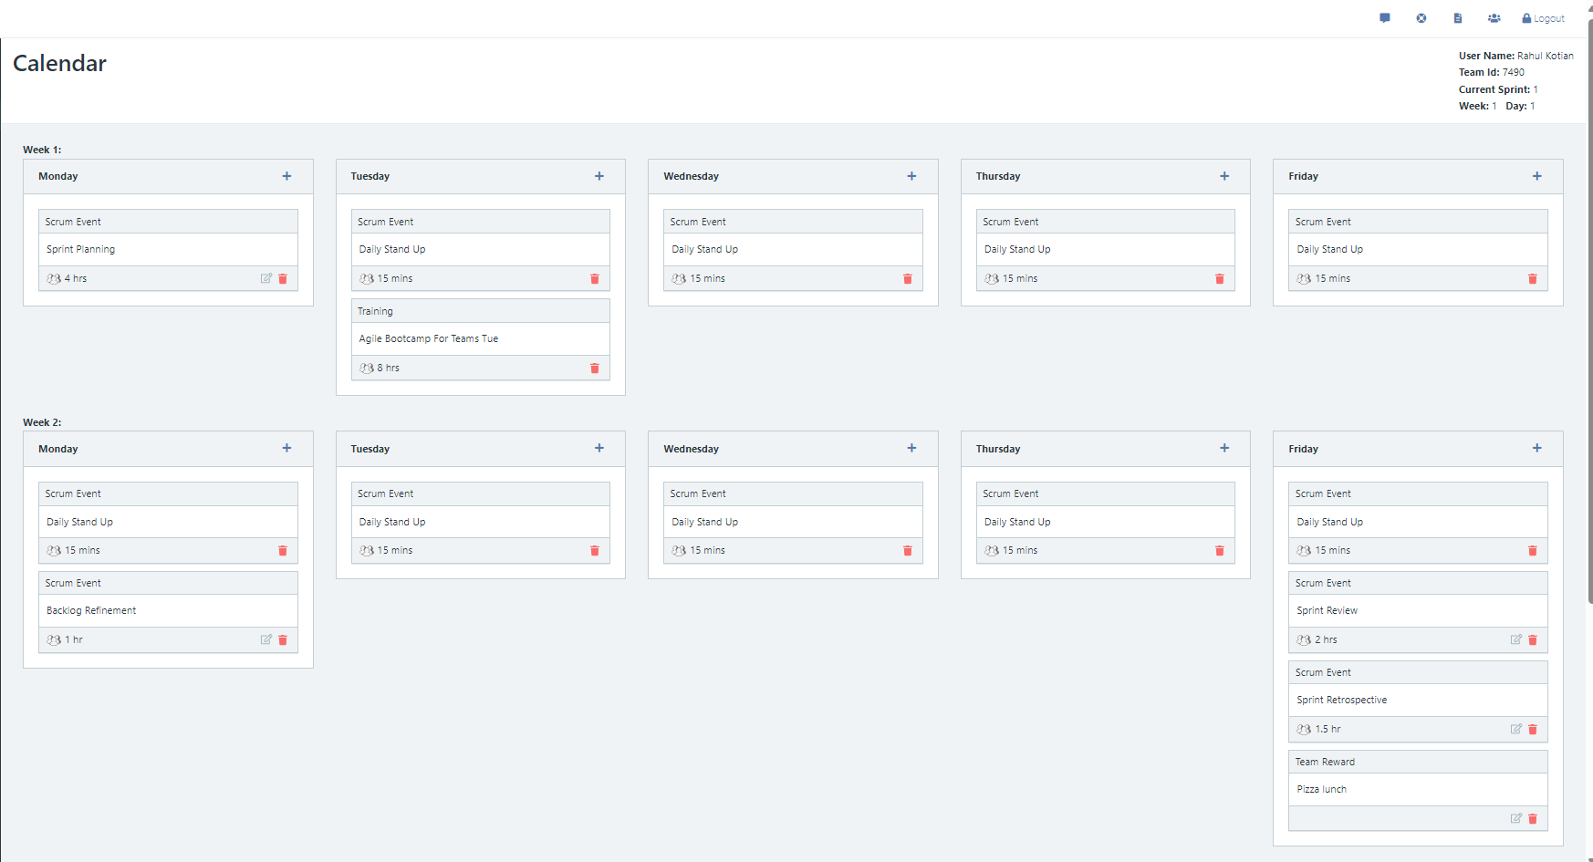

**Answer**

Explain the reason why you have scheduled the meetings listed shown on your calendar.

**Answer**

**Burn Down**

After competing sprint 1, paste a screen shot of the sprint 1 Burn Down Chart below.

**Answer**

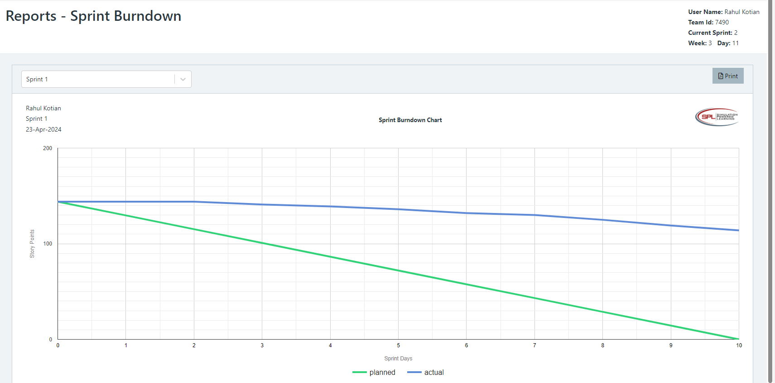

**Velocity Trend**

After competing sprint 1, paste the sprint 1 Velocity Chart below:

**Answer**

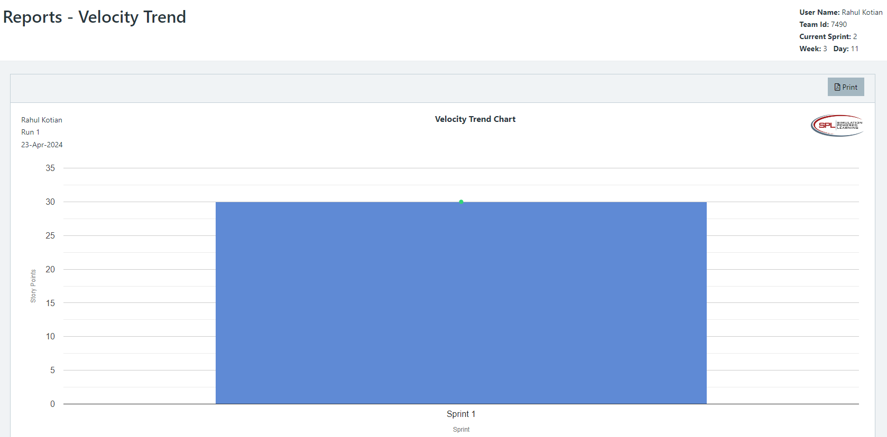

**Retrospective Meeting:**

How did you do in this Sprint?

**Answer**

What problems, if any, did you encounter as you were executing the sprint?

**Answer**

What changes, if any, are you are planning to make in the next sprint?

**Answer**

**Answer following questions based on this Sprint:**

What is the velocity (in story points) for the sprint?

**Answer**

What is the average velocity, minimum velocity, and maximum velocity (in story points) for the project across all sprints that have been completed so far?

**Answer**

Average : 30

Min : 30

Max: 30

Based on the current status of your project, do you believe that you will be able to complete the mandatory (or required) stories in the product backlog within the four sprints?  Explain your answer.

**Answer**

Based on the current status of your project, do you believe that you will be able to complete all stories in the product backlog within the four sprints planned? Explain your answer.

**Answer**

**Sprint 2 - Week 3 and Week 4 (10 Points)**

**Product Backlog (one screen shot for the sprint)**

Paste the screen shot of your Product Backlog below.

**Answer**

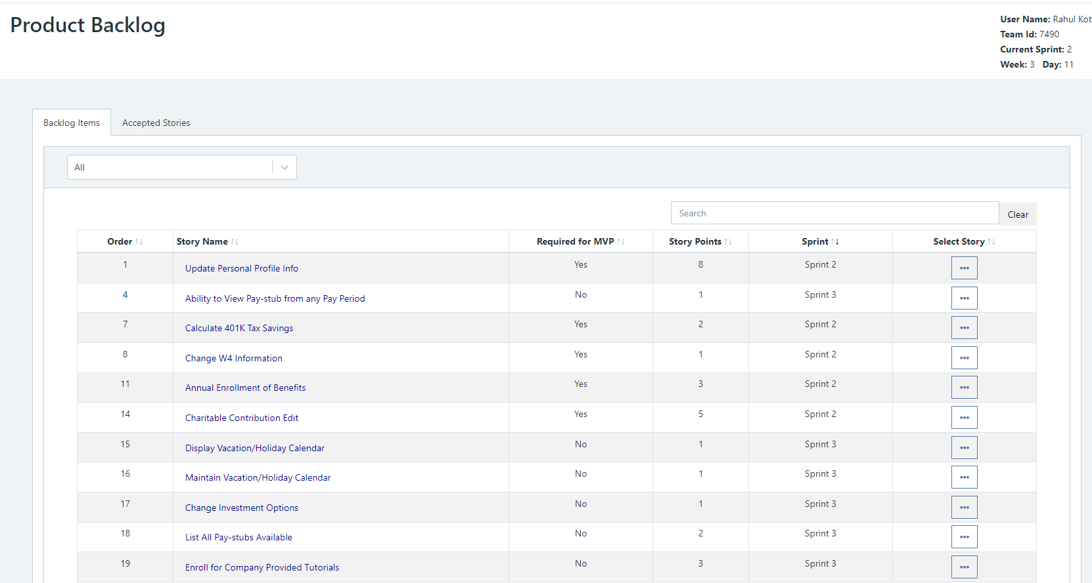

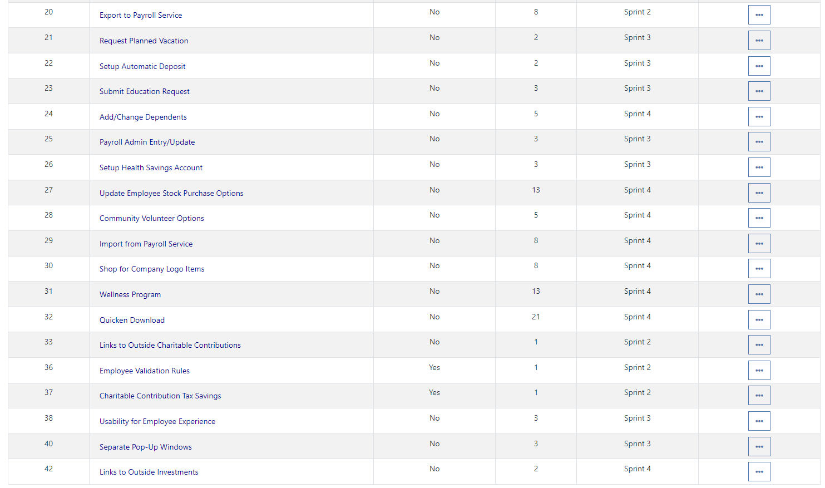

Please explain what you did in grooming the user stories in your Product Backlog and your reasoning for these decisions.

**Answer**

**Add more detail to User stories 36, 17 and 37 .**

**Scrum Board**

Scrum Board screen shot before sprint 2 has started

**Answer**

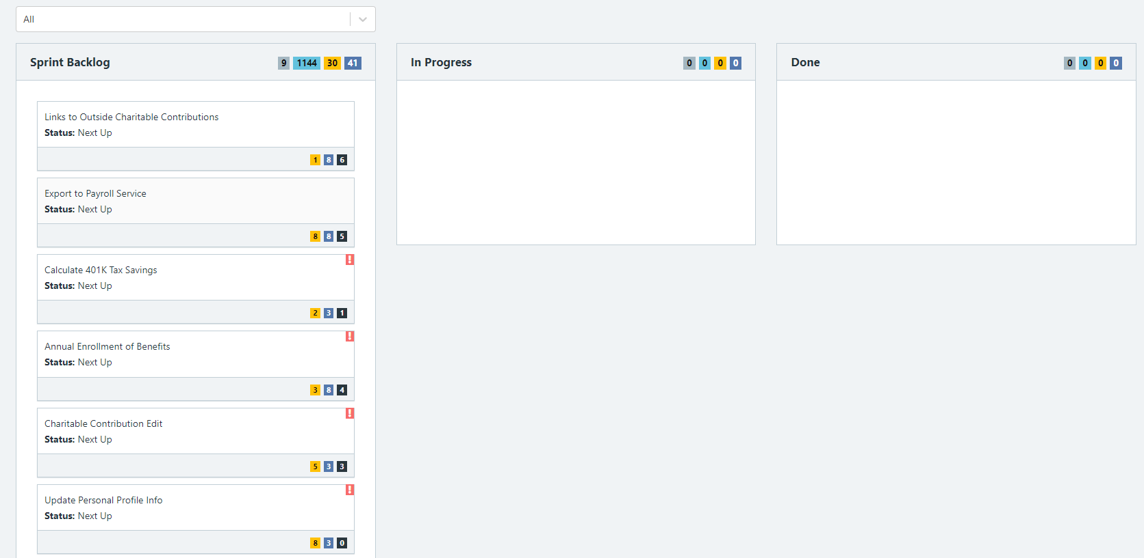

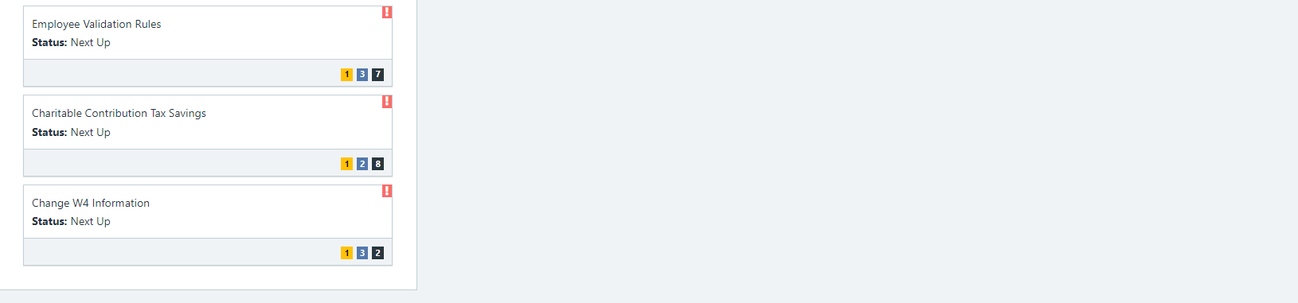

Scrum Board screen shot after 1st week of sprint 2

**Answer**

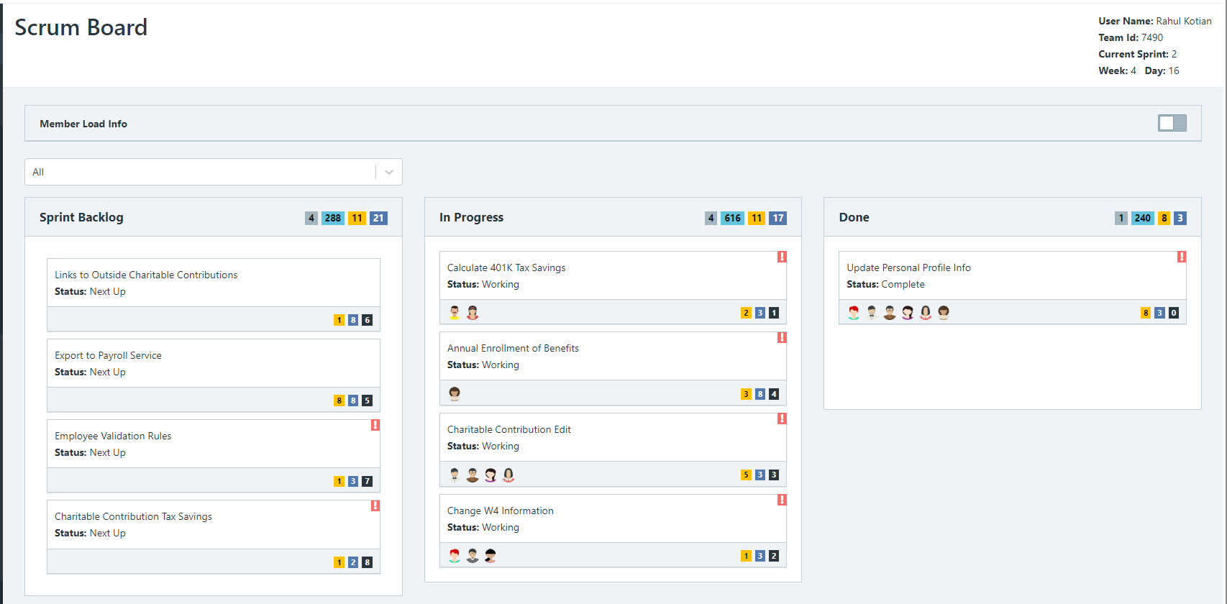

Scrum Board screen shot after 2nd week of sprint 2

**Answer**

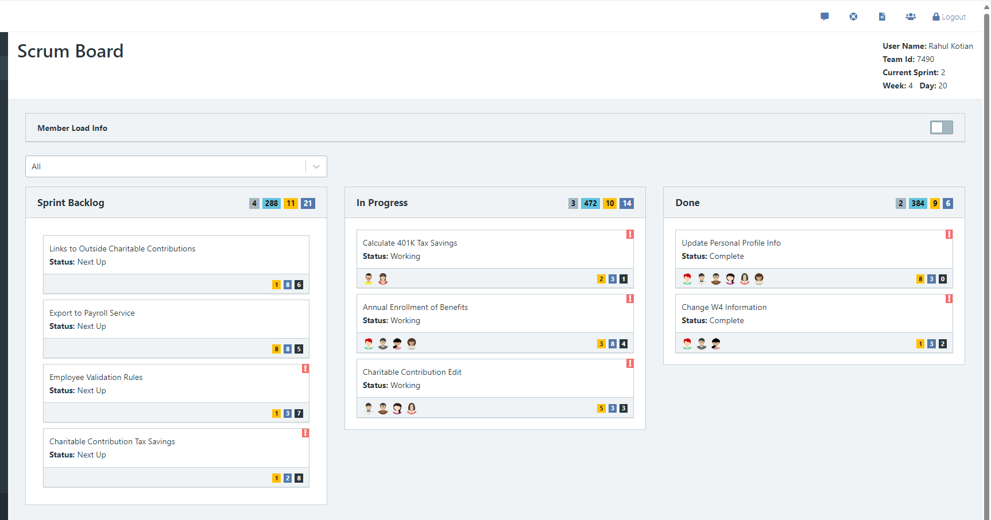

**Calendar**

Paste the screen shot of your calendar for sprint 2

**Answer**

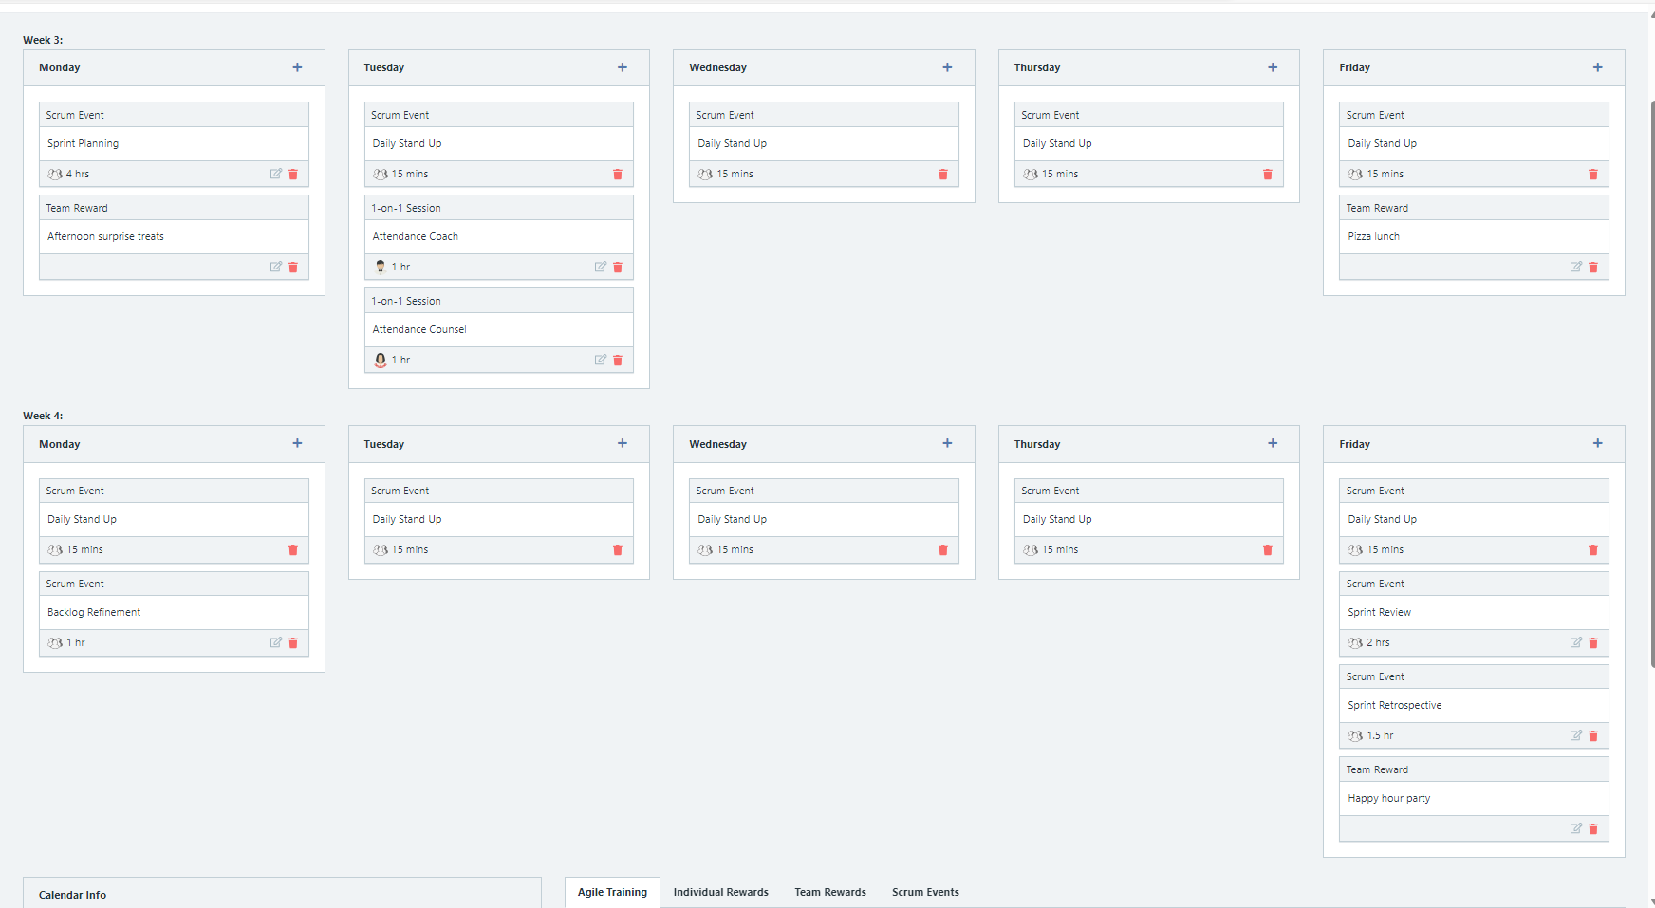

Explain the reason why you have scheduled the meetings listed shown on your calendar (if any)?

**Answer**

**BurnDown**

After competing sprint 2, paste a screen shot of the sprint 2 Burn Down Chart below.

**Answer**

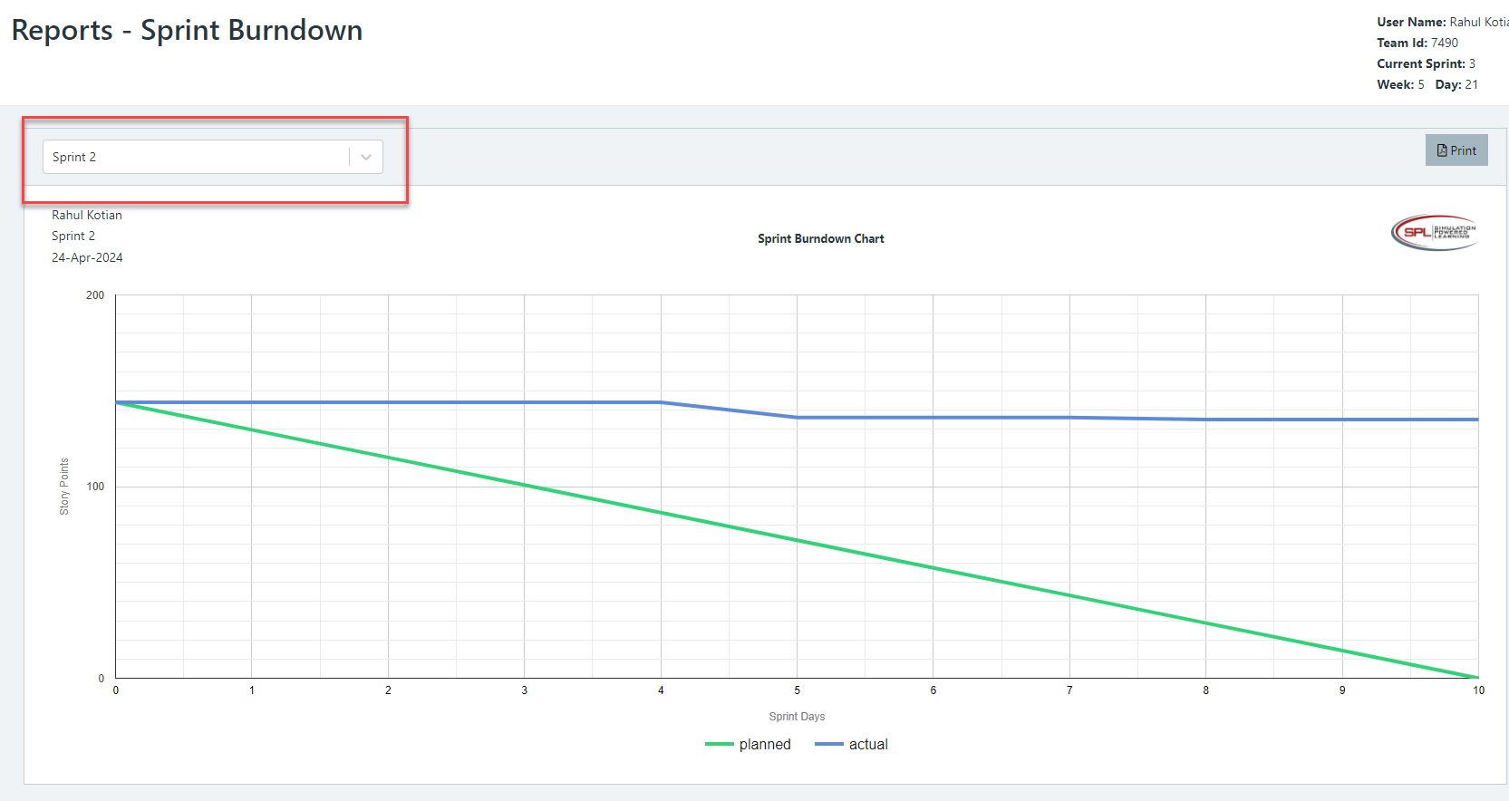

**Velocity Trend**

After competing sprint 2, paste the sprint 2 Velocity Chart below:

**Answer**

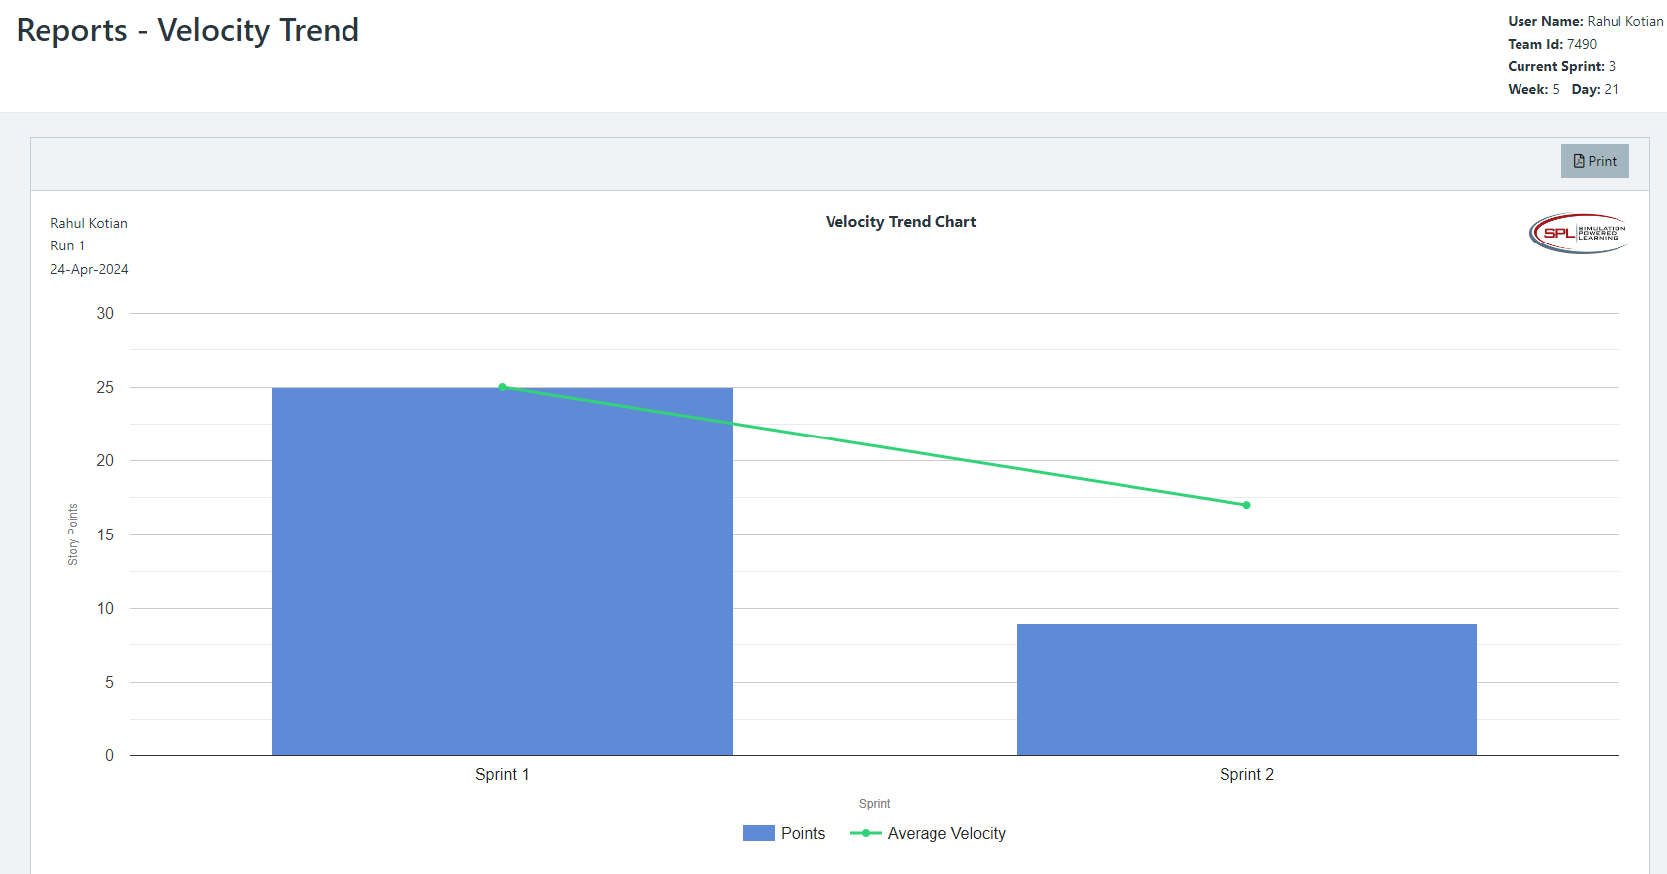

**Retrospective Meeting:**

How did you do in this Sprint?

**Answer**

What problems, if any, did you encounter as you were executing the sprint?

**Answer**

What changes, if any, are you are planning to make in the next sprint?

**Answer**

**Answer following questions based on this Sprint:**

What is the velocity (in story points) for the sprint?

**Answer**

**9 story points**

What is the average velocity, minimum velocity, and maximum velocity (in story points) for the project across all sprints that have been completed so far?

**Answer**

**Avg velocity: 17**

**Min velocity: 9**

**Max : 25**

Based on the current status of your project, do you believe that you will be able to complete the mandatory (or required) stories in the product backlog within the four sprints?  Explain your answer.

**Answer**

**No**

Based on the current status of your project, do you believe that you will be able to complete all stories in the product backlog within the four sprints planned? Explain your answer.

**Answer**

Maybe?

**Sprint 3 - Week 5 and Week 6 (10 Points)**

**Product Backlog (one screen shot for sprint 3)**

* Paste the screen shot of your product backlog below.

**Answer**

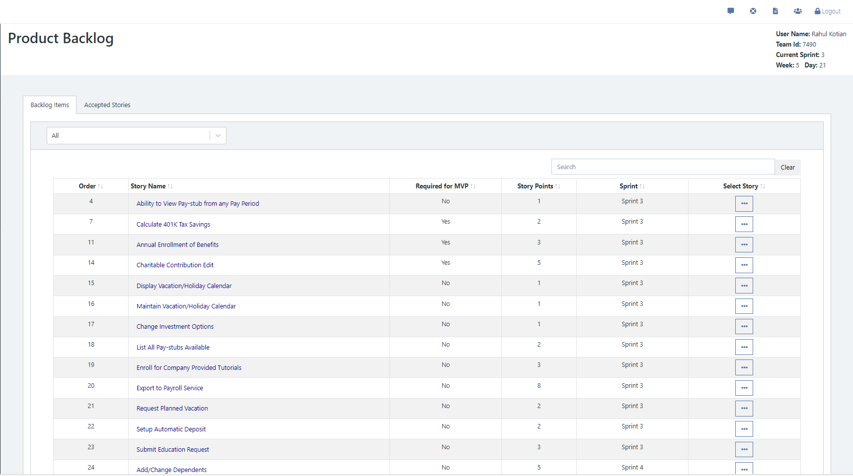

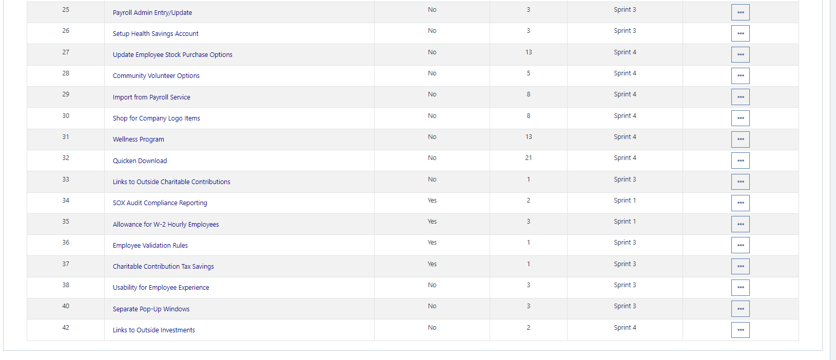

* Please explain what you did in grooming the user stories in your Product Backlog and your reasoning for these decisions.

**Answer**

**Prioritize MVP stories**

**Scrum Board**

Scrum Board screen shot before sprint 3 has Started

**Answer**

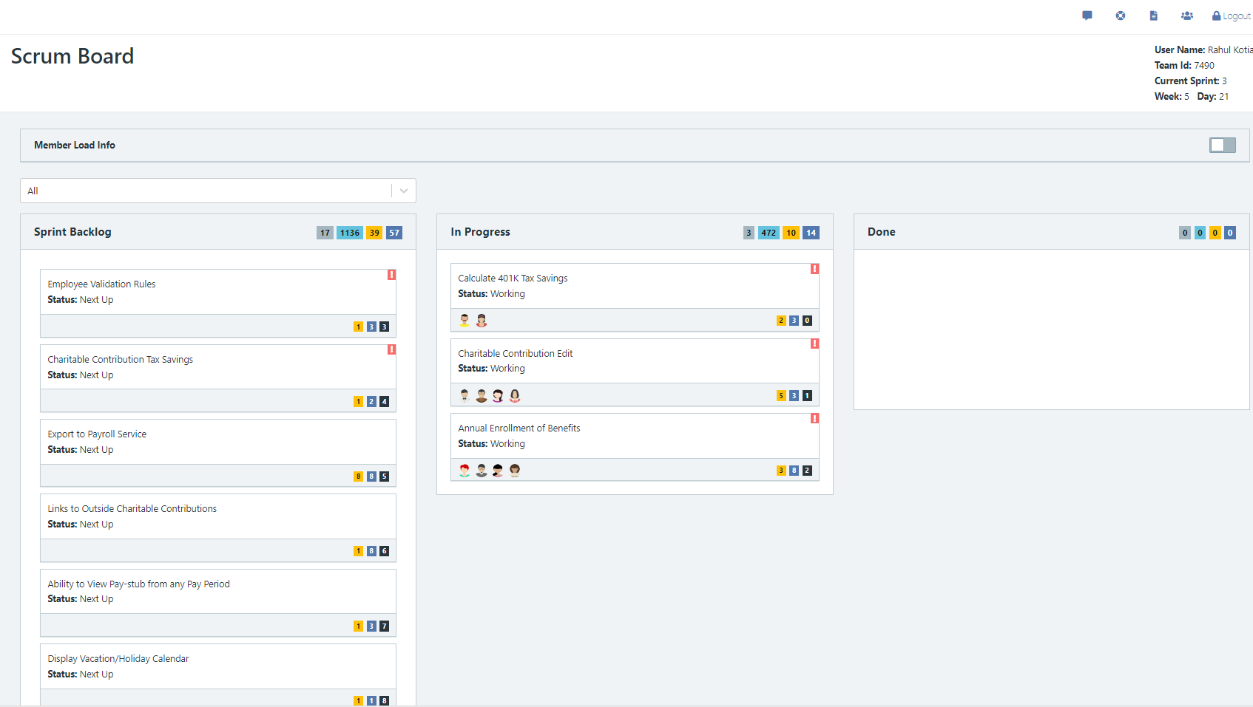

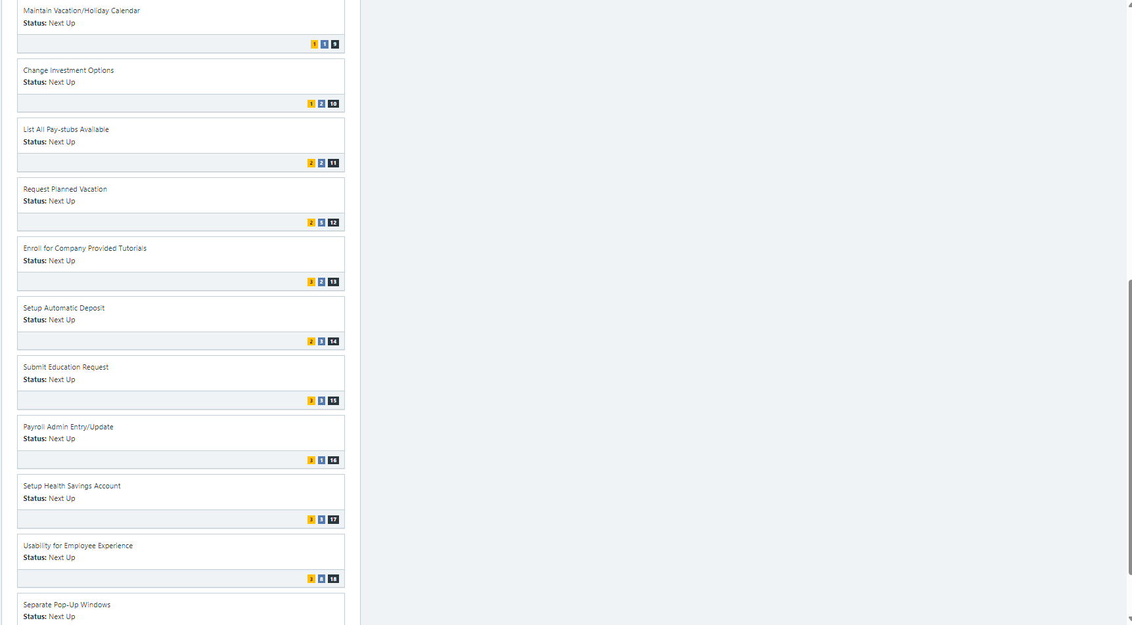

Scrum Board screen shot after 1st week of sprint 3

**Answer**

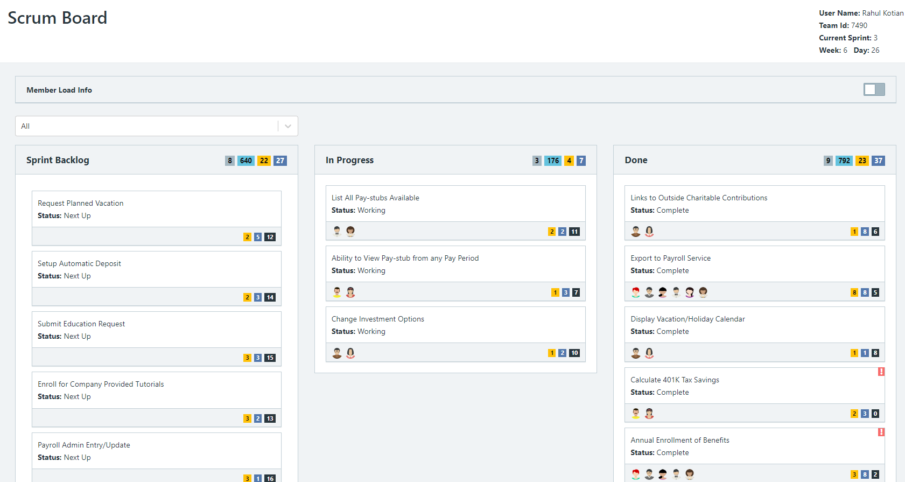

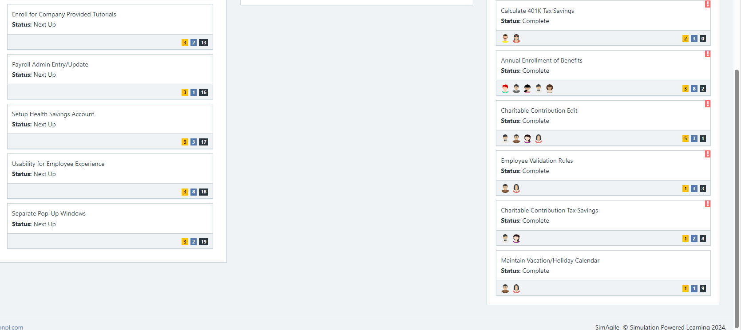

Scrum Board screen shot after 2nd week of sprint 3

**Answer**

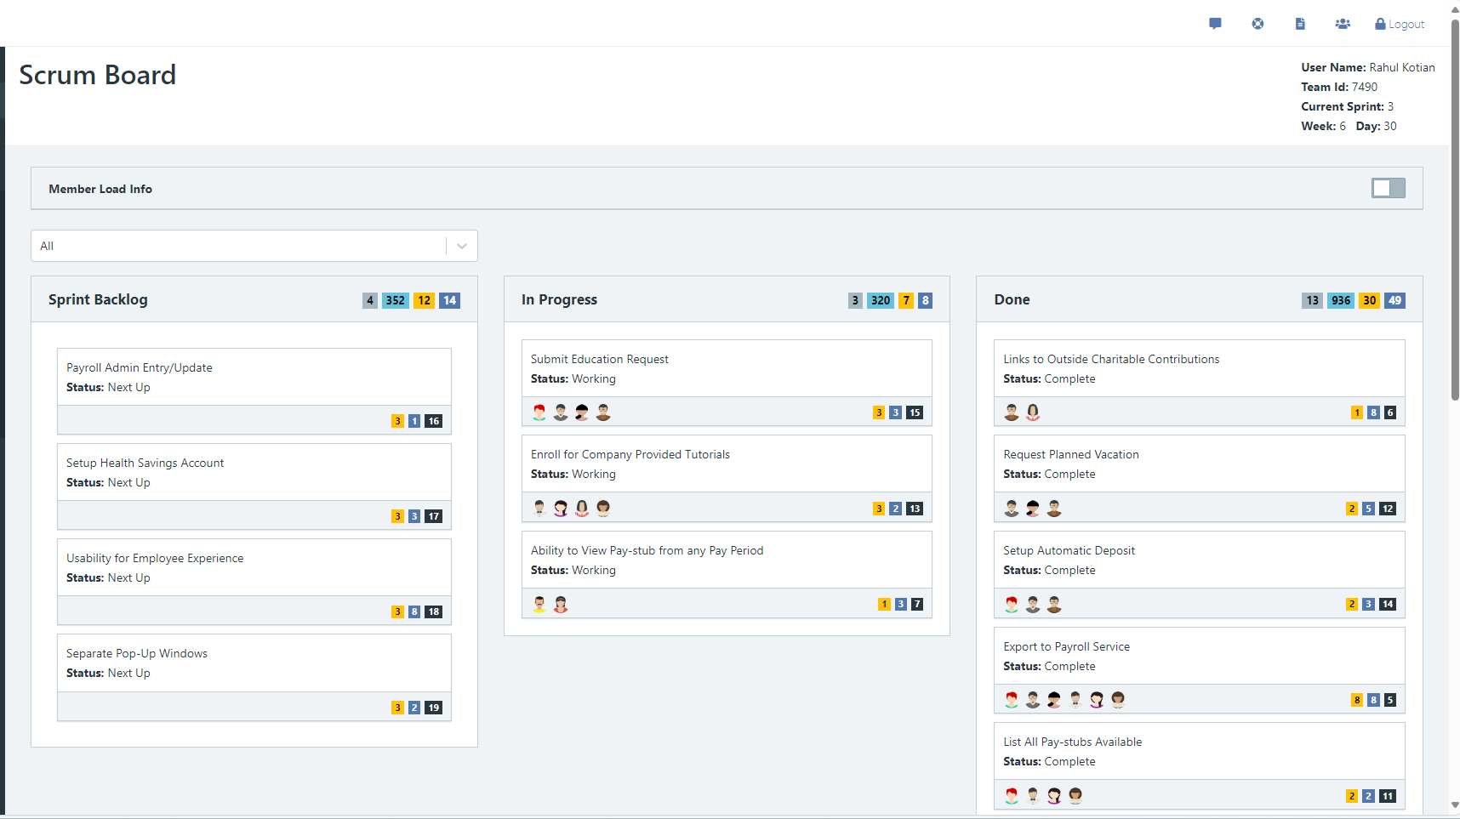

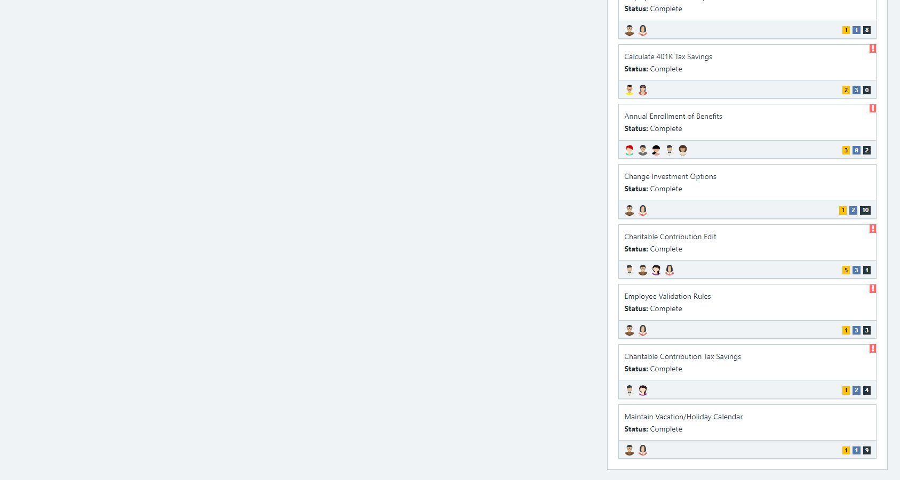

**Calendar**

* Paste the screen shot of your calendar for sprint 3

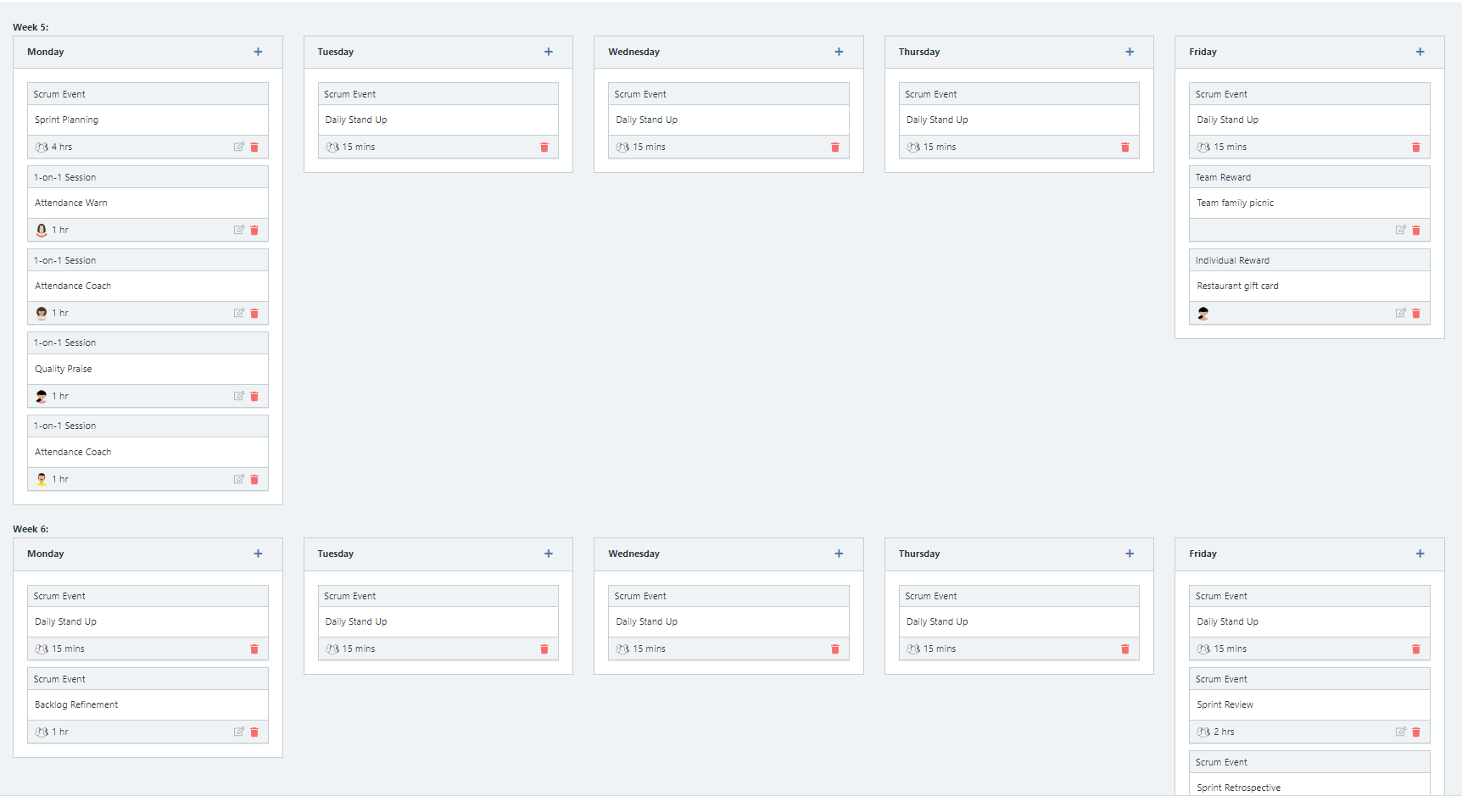

Explain the reason why you have scheduled the meetings listed shown on your calendar (if any)?

**Answer**

**BurnDown**

After competing sprint 3, paste a screen shot of the sprint 3 Burn Down Chart below.

**Answer**

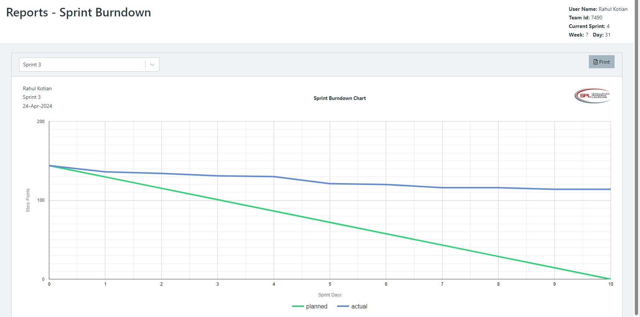

**Velocity Trend**

After competing sprint 3, paste the sprint 3 Velocity Chart below:

**Answer**

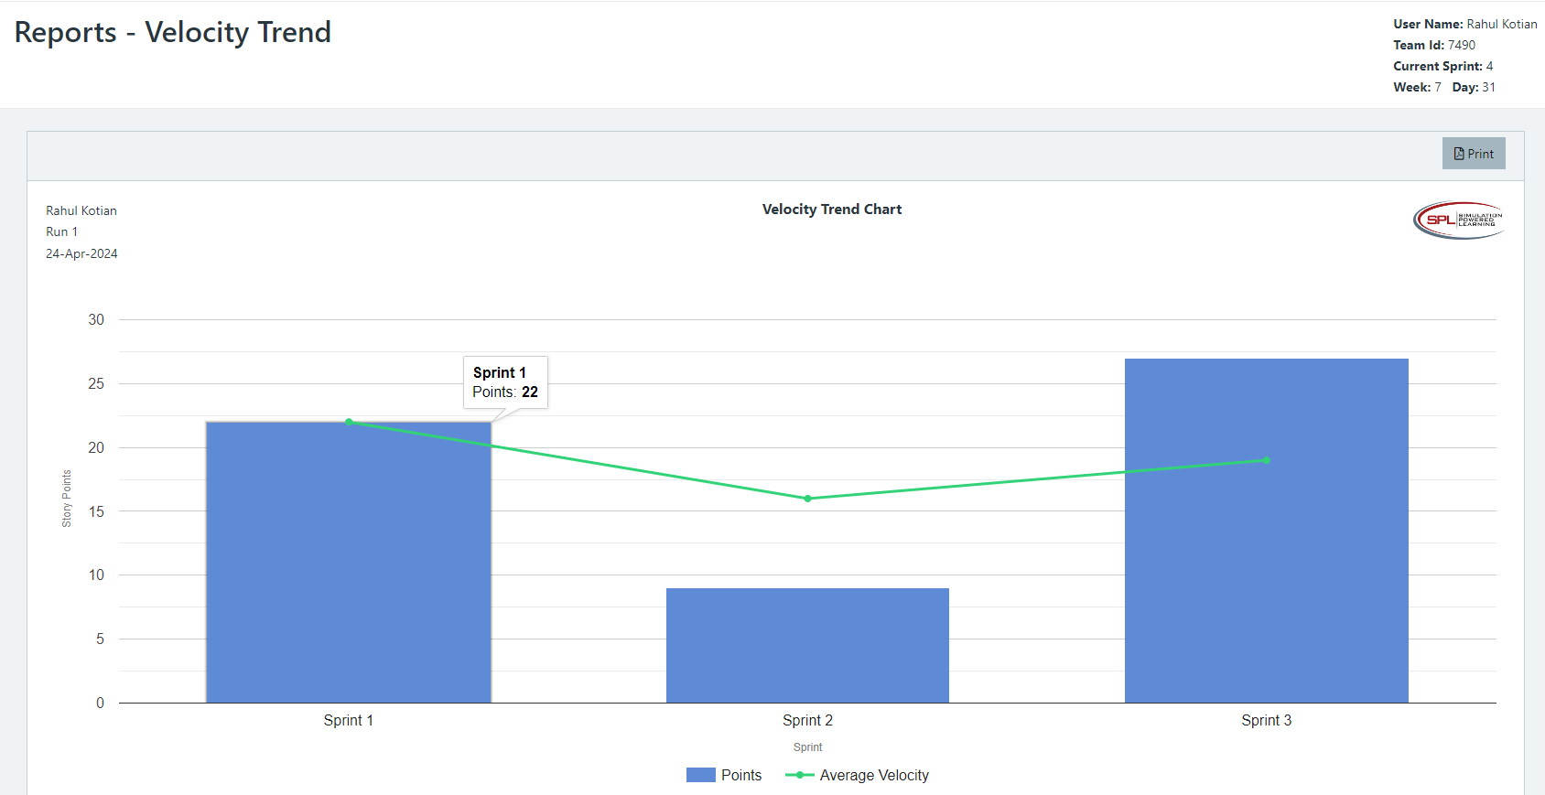

**Retrospective Meeting:**

How did you do in this sprint?

**Answer**

What problems, if any, did you encounter as you were executing the sprint?

**Answer**

What changes, if any, are you are planning to make in the next sprint?

**Answer**

**Answer following questions based on this Sprint:**

What is the velocity (in story points) for the sprint?

**Answer**

**27 points**

What is the average velocity, minimum velocity, and maximum velocity (in story points) for the project across all sprints that have been completed so far?

**Answer**

Average: 19

Max: 27

Min : 9

Based on the current status of your project, do you believe that you will be able to complete the mandatory (or required) stories in the product backlog within the four sprints?  Explain your answer.

**Answer**

4. Based on the current status of your project, do you believe that you will be able to complete all stories in the product backlog within the four sprints planned? Explain your answer.

**Answer**

**Sprint 4 - Week 7 and Week 8 (10 Points)**

**Product Backlog (one screen shot for sprint 4)**

* Paste the screen shot of your Product Backlog below.

**Answer**

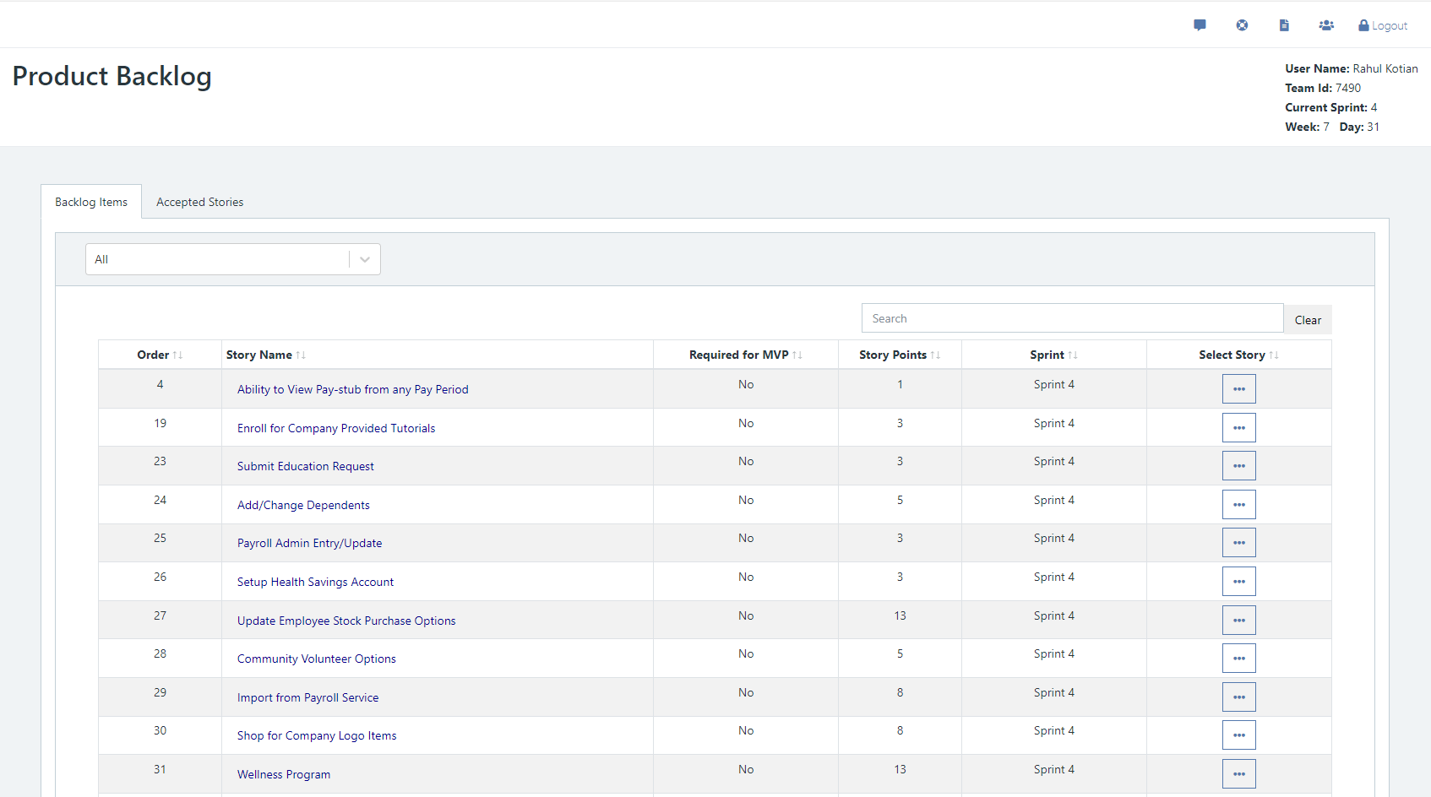

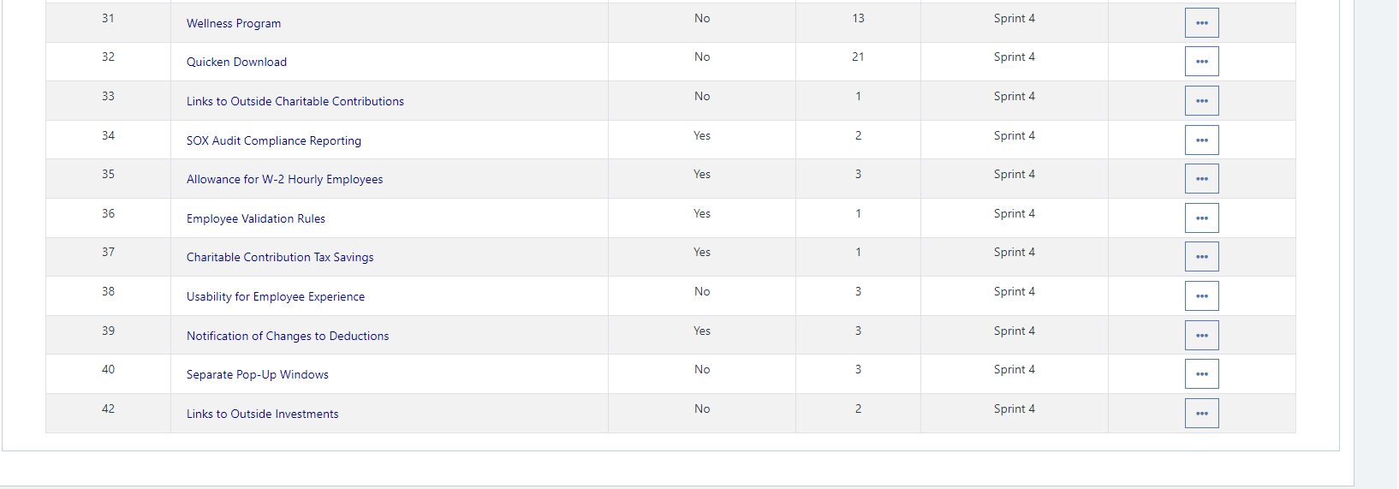

* Please explain what you did in grooming the user stories in your Product Backlog and your reasoning for these decisions.

**Answer**

**Discussed the new stories that were added to the backlog and prioritized them.**

**Scrum Board**

Scrum Board screen shot before sprint 4 has started

**Answer**

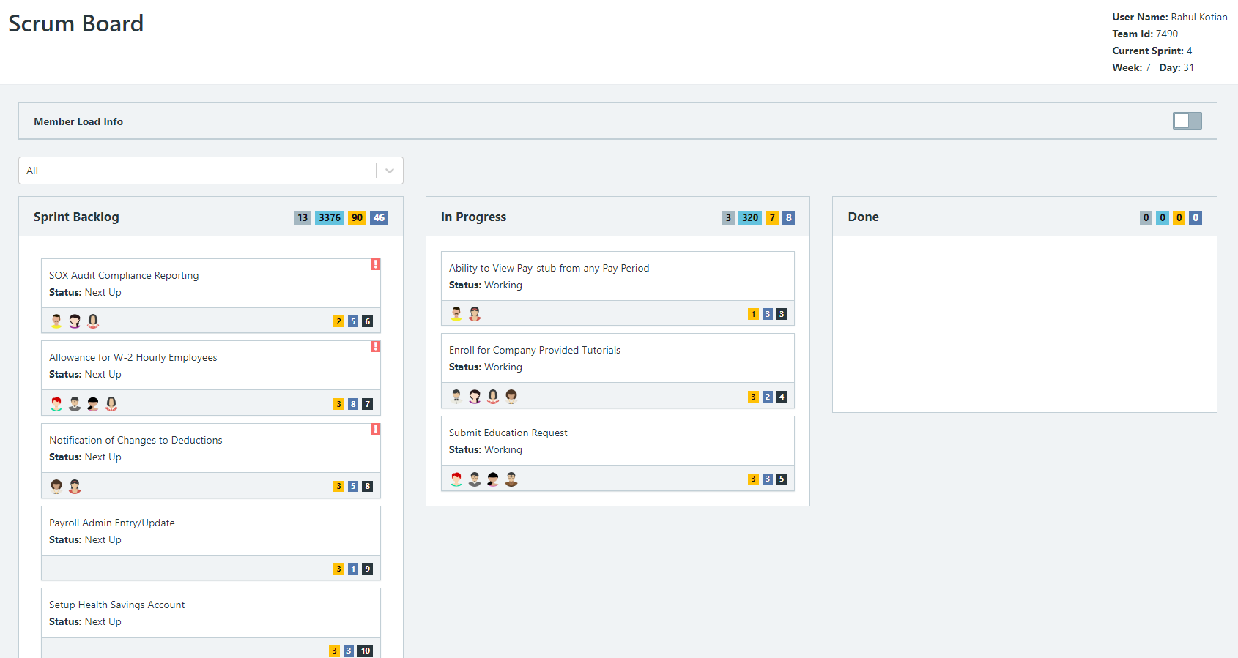

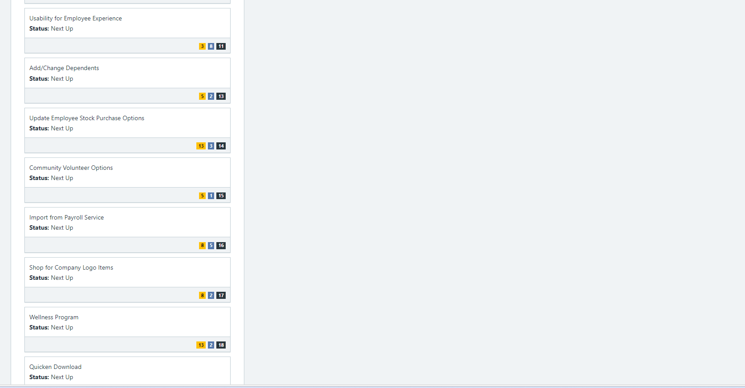

Scrum Board screen shot after 1st week of sprint 4

**Answer**

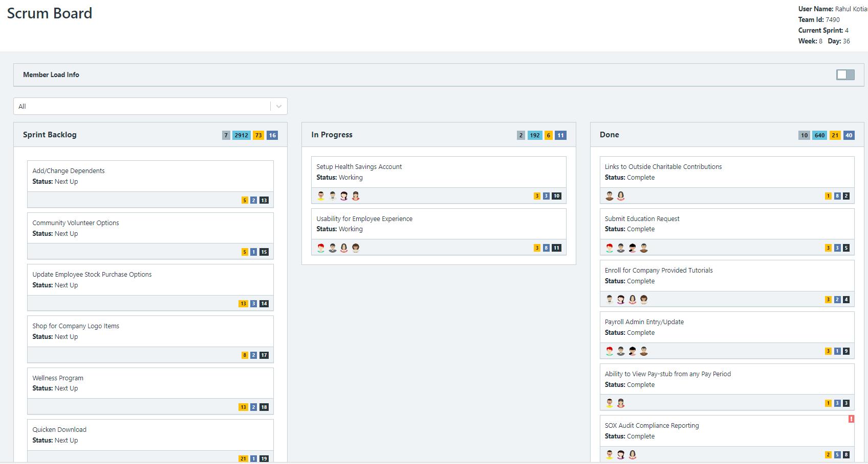

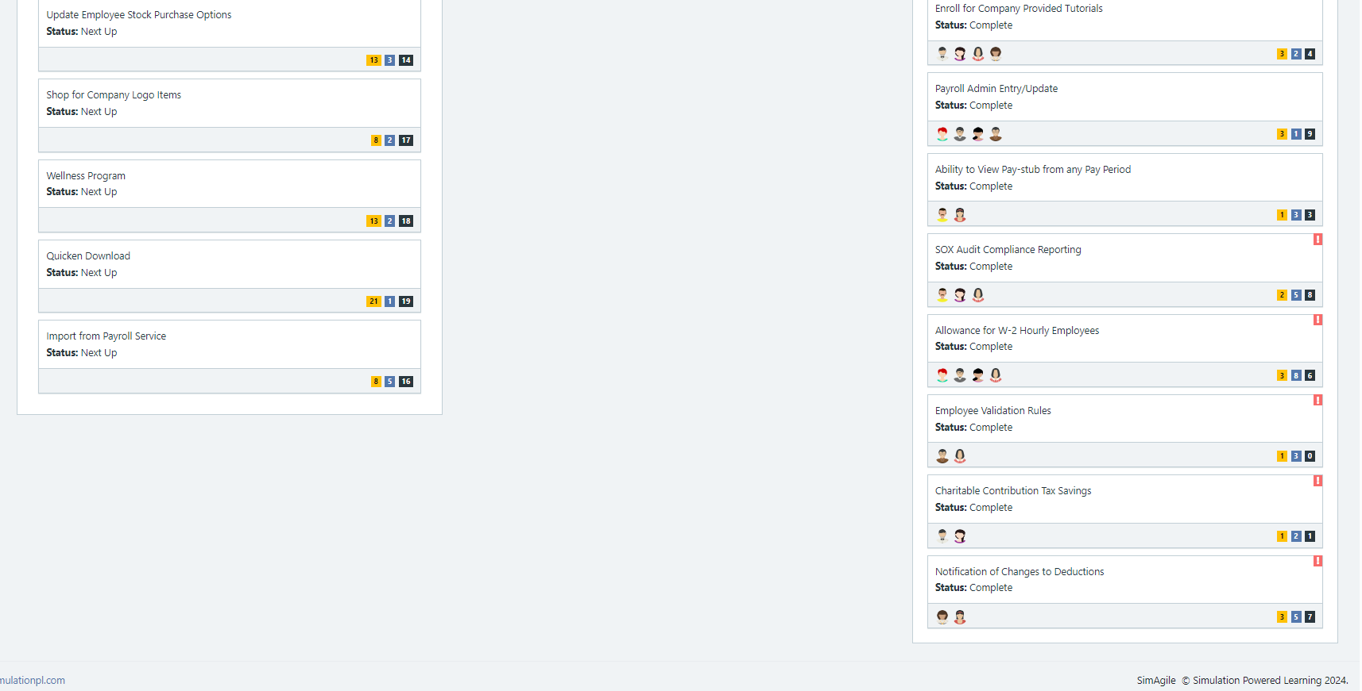

Scrum Board screen shot after 2nd week of Sprint 4

**Answer**

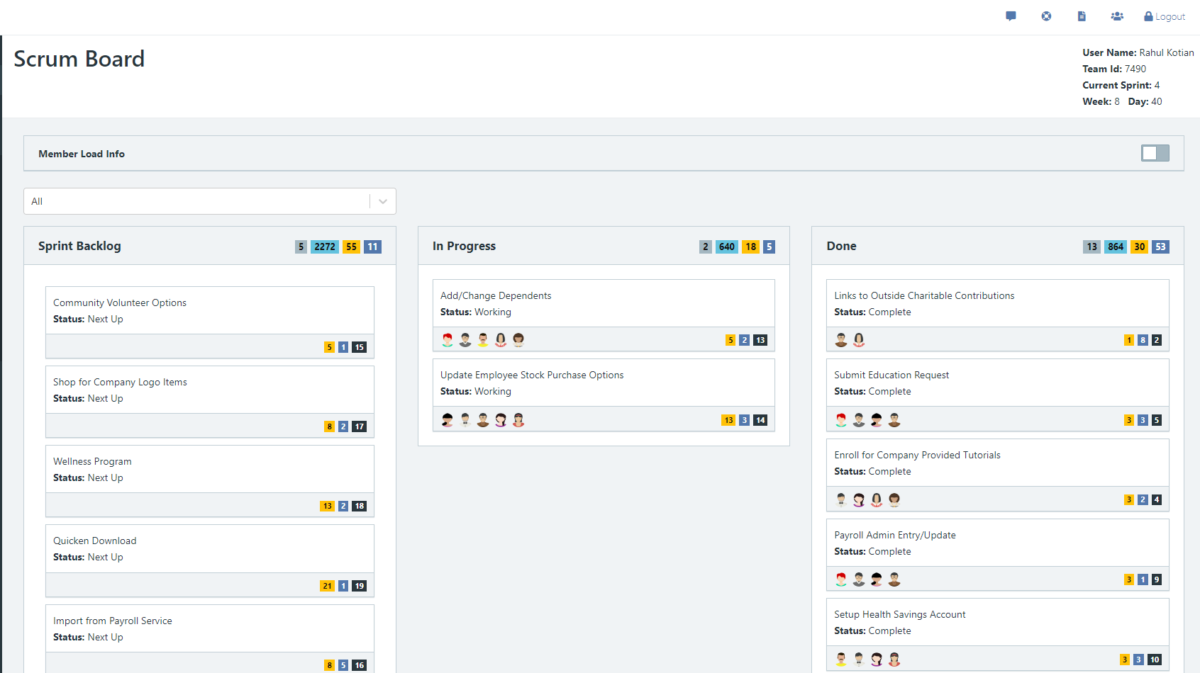

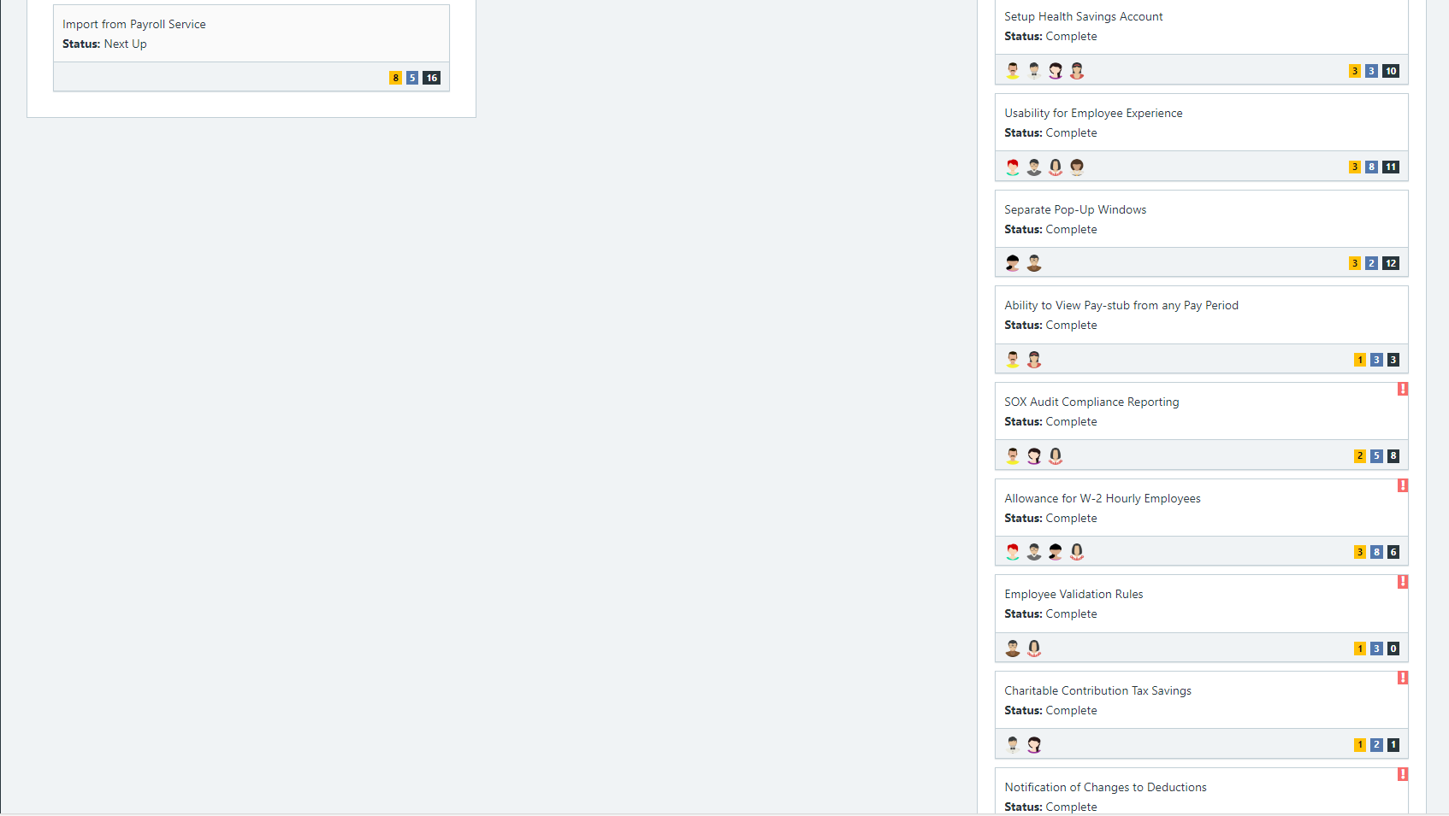

**Calendar**

Paste the screen shot of your Calendar for Sprint 4

**Answer**

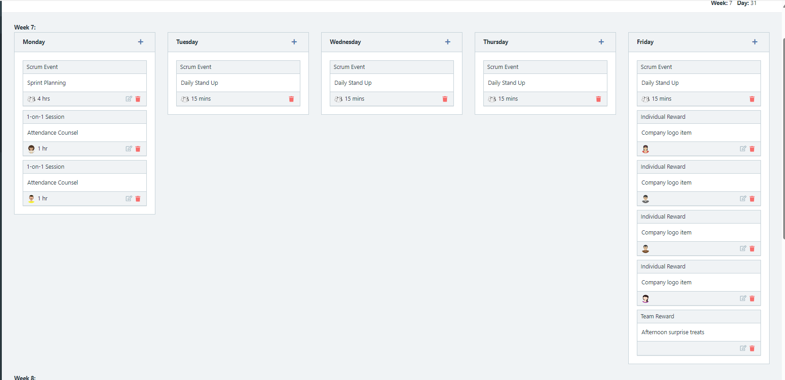

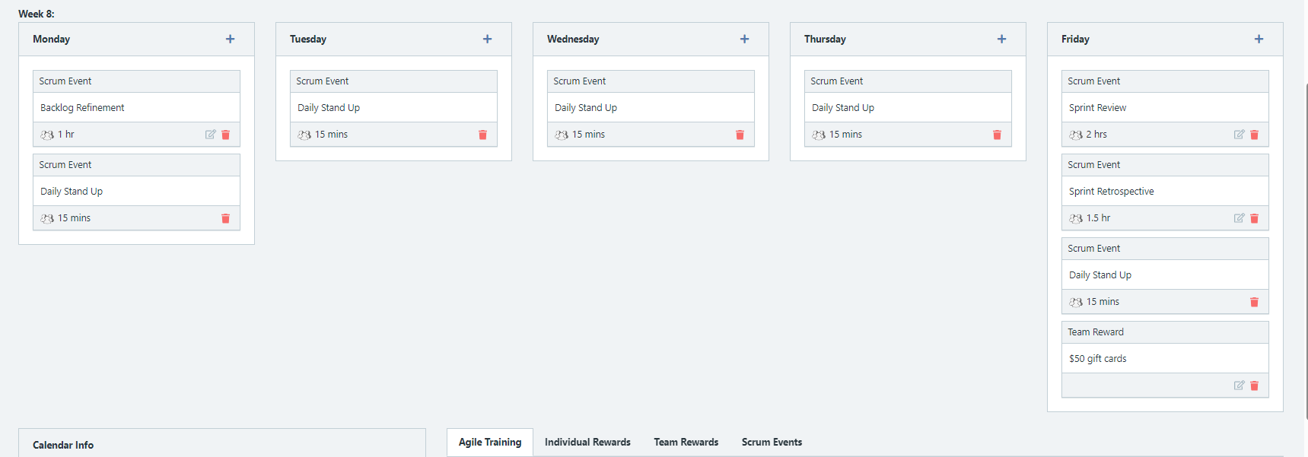

Explain the reason why you have scheduled the meetings listed shown on your calendar (if any)?

**Answer**

**Retrospective Meeting:**

How did you do in this sprint?

**Answer**

What problems, if any, did you encounter as you were executing the sprint?

**Answer**

What changes, if any, are you are planning to make in the next sprint?

**Answer**

**Answer following questions based on this Sprint:**

What is the velocity (in story points) for the sprint?

**Answer**

30 points

What is the average velocity, minimum velocity, and maximum velocity (in story points) for the project across all sprints that have been completed so far?

**Answer**

Average: 22

Min: 9

Max: 30

Did you deliver all required functionality needed for the MVP?  Explain your answer.

**Answer Yes**

Did you deliver all the user stories in the product backlog? What were the three most significant items that effected your team’s performance?

**Answer**